Does it cost anything?

No, our service is free.

Who is it for?

Social prescribing is available to everyone.

How do I access the service?

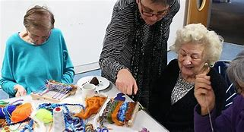

You can talk to your GP, Health Care Professional or surgery staff and they will organise for one of our Social Prescribers to contact you.

Brook Lane Surgery
01489 575191
Lockswood Surgery
01489 576708
Stubbington Medical Practice
01329 6644231

Coastal PCN

Brook Lane Surgery, Lockswood Surgery, Stubbington Medical Practice

Social Prescribing

Did you know?

Your doctor isn't the only person who can help make you feel better.

We can help you improve your health and wellbeing through social prescription.

What is Social Prescribing?

We know that taking care of your wellbeing involves more than just health.

With Social Prescribing you can get specialist support for more than medical issues.

Your Social Prescriber is there to listen to you, and put you in touch with the people and activities that might help your wellbeing.

What support can I get?

We can help you with a range of issues, including:
- Social isolation / Loneliness
- Emotional wellbeing
- Healthy lifestyle choices
- Loss of confidence / purpose
- Life change events such as birth, retirement, bereavement.
- Accessing work, training and volunteering.
- Finances, housing and legal advice.

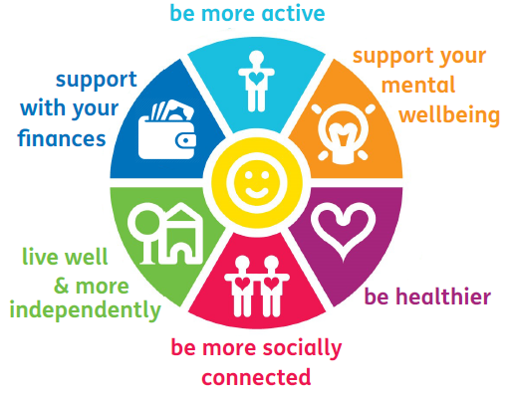

What are the benefits?

- Improve your mental and physical health
- Meet new people
- Learn a new skill or participate in a new activity
- Increase self-confidence and self esteem
- Better quality of life
- Get involved in your community

