Stubbington Medica Practice Newsletter

CONTENTS
Appointment booking | 1
system
Online Access | 2
Appointment Stats | 3
Autumn COVI and | 3
Flu Vaccine
World Champion | 4
Bank Holidays | 4
Face Mask Policy | 4

NHS APP FEATURES
- Get your NHS COVID Pass
- Order repeat prescriptions
- Book appointments
- Get health advice
- View your health record
- For more information go to
https://www.nhs.uk/nhs-app/

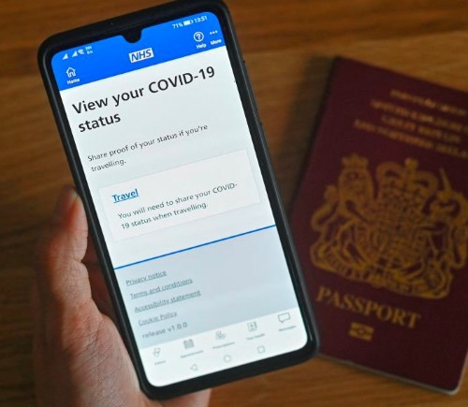
APPOINTMENT BOOKING
SYSTEM
We appreciate the appointment booking system has not been ideal, especially with the unprecedented demand that GP practices have been experiencing. We are aware of our patient demographics and try to consider patients of all ages, giving fair access to all.

We have reviewed our appointment system since the easing of COVID restrictions and have trialled a new appointment booking system from the 9th May 2022. There were some issues initially but now are pleased to say the trial was a success and we are implementing the current system on a permanent basis.

Appointments for GPs are bookable 7 days in advance. Many of these appointments are bookable online for patients that prefer this method, online appointments are released weekdays at 6pm. For those who would rather book via telephone, appointments are released at 8am weekdays by calling the practice on 01329 664231. Patients will be able to choose, at the time of booking, whether they would like the appointment to be via telephone or face to face.

The urgent care team list runs from 8:00am to 11:00am, and 2:00pm to 5:15pm. Our Urgent Care Team comprises of Advanced Nurse Practitioners and Urgent Care Sisters, who are senior health care professionals with additional training, qualifications and experience allowing them to undertake tasks once performed by Doctors. They are experienced at taking a patient history, assessing symptoms, making a diagnosis and instigating treatment or referrals as required.

Nurse appointments are released 2 weeks in advance and can be booked by calling the practice preferably after 10:00am as our phone lines are generally quieter. Smear and blood test appointments are bookable via your online access provider.

You can contact the practice via eConsult. eConsult is a great way to contact the practice for administrative needs such as sick notes, medication queries, referral queries. Please be aware that completing an eConsult will not mean a clinician will call you or an appointment will be booked. If you need to be examined or need a discussion with a clinician please book an appointment or if your issue is urgent please call to be added to the urgent care team list.

We encourage patients to update the practice if they have any disabilities especially if this means they would have difficulties contacting the practice. We can then update your medical records and tailor the way you can contact the practice on a case by case basis.

P AT I E N T O N L I N E A C C E S S

W H AT I S P AT I E N T O N L I N E A C C E S S ?
Patient online access is an online service in which patients can view their medical history, book appointments and order repeat prescriptions. The main 2 online access providers are Patient Access and the NHS app but there are a lot of online access providers our patients can choose from. Its up to the individual which online access provider they choose.

N H S A P P
Owned and run by the NHS, the NHS App is a simple and secure way to access a range of NHS services on your smartphone or tablet. You can also access NHS App services from the browser on your desktop or laptop computer. To find out more go to www.nhs.uk/app.
The NHS App is free to download from the App Store and Google Play. After you download the app, you will need to set up an NHS login and prove who you are. The app then securely connects to information from your GP surgery. If you cannot prove who are via the app or you cannot access your medical records via the NHS app please contact the practice. To use the NHS App you must be aged 13 or over and registered with a GP surgery in England.
Covid passes are only available on the NHS app.

P AT I E N T A C C E S S
Patient Access allows you to book GP appointments, order repeat prescriptions and view your health records via your mobile or home computer. There is also a patient access app which can be downloaded from the App Store and Google Play. To find out more please see www.patientaccess.com

N H S A P P V P AT I E N T A C C E S S
Both the NHS app and patient access are secure, trusted providers for patients to use to order prescriptions, view medical records and book appointments. It will be down to the individual patient to decide which provider they would like to use. The table below compares the features of the NHS and Patient Access.
What is accessible? | NHS App | Patient Access
Book appointments | Yes | Yes
Order repeat prescriptions | Yes | Yes
View health record | Yes | Yes
Track referrals | Yes | No
COVID pass | Yes | No
Access 111 online | Yes | No
Access eConsult | Yes | No
Please see our website for more information on patient online access. You will find all the relevant forms which need to be completed for the practice to set up patient online access.
www.stubbingtonmedical.co.uk/pages/Online-Access

O N L I N E A P P O I N T M E N T B O O K I N G
Please ensure when booking an online appointments you are booking the correct appointment type. Please be mindful that the appointment is with the correct clinician. For example we have an in house physio team which can help with bone, muscle and joint problems. Instead of booking a GP appointment it would be more applicable to book a physio appointment. If you enquiry is administrative you could complete an eConsult in place of booking a GP appointment. The demand for GP appointments is very high still so please book sensibly and if you cannot make the appointment please contact the practice to cancel.

A P P O I N T M E N T S TATS

From 1st April-30th June 2022 we have provided patients with 3,011 GP appointments, 4,398 Urgent Care Team appointments, 3,457 Nurse/HCA appointments and the practice has received 1,396 eConsults.  Sadly we also had 220 did not attend. This is up 37% from the last quarter and amounts to on average 20 hours of clinical time being wasted each month!  We would like to politely remind patients to please cancel their appointment if they cannot make it. You can cancel an appointment by calling the practice option 1, then option 1 and leave a message, by emailing us at fgccg.stubbington-admin@nhs.net or you come to practice during our opening hours and advise our front desk staff. | 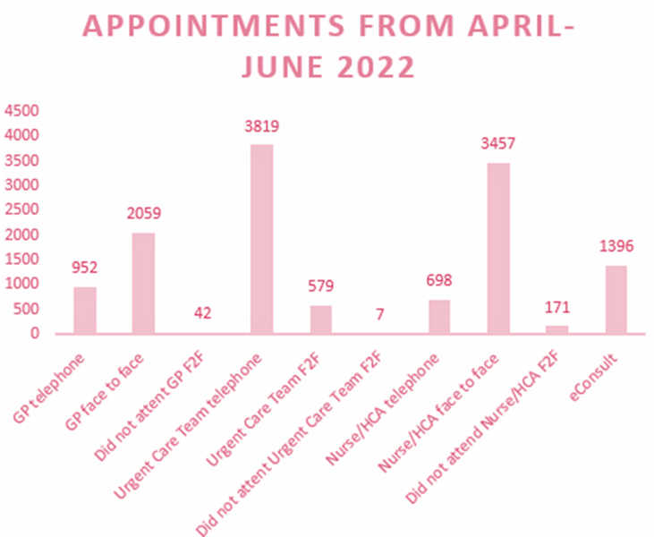

A U T U M N C OV I D A N D F LU V A C C I N E S
The COVID spring booster programme has now finished at the practice. We would like to thank all the staff at our practice, Lockswood surgery, Brooklane surgery along with the PPG members and volunteers who have helped over the past few month to vaccinate our most vulnerable patients. As well as those who had nominated the Coastal PCN for a hidden heros award. Thank you!

We are now starting to organise our autumn covid and flu vaccines and preparing logistics for how we are going to deliver the vaccines.
We are expecting our flu vaccines to arrive in early September and to start running clinics soon after. The criteria for the flu vaccines is:
- all children aged 2 or 3 years on 31 August 2022
- all primary school aged children from reception to Year 6
- those aged 6 months to under 65 years in clinical risk groups
- pregnant women
- those aged 65 years and over
- those in long-stay residential care homes carers
- close contacts of immunocompromised individuals

The criteria currently for the autumn COVID booster is:
- residents in a care home for older adults and staff
- frontline health and social care workers
- all those 65 years of age and over
- adults aged 16 to 64 years who are in a clinical risk group
please note we are still awaiting full guidance for the autumn COVID booster programme, please see check our website for updates.

W O R L D C H A M PI O N

Our administrator Abi went to the Dance World Cup held in San Sebastian in Spain.
Countries from all over the world were competing against each other.
Abi and her trio performed a Ukrainian Ribbons National Dance in the National section and competed against 16 other countries.
Congratulations to Abi and her dance trio for winning GOLD and becoming world champions!!!

S U M M E R B A N K | F A C E M A S K P O L I C Y
H O L I DAY
On Monday 29th | Due to COVID cases
 | rising we are now asking
August 2022 the
 | patients to wear face
practice will be
 | mask upon entering the
closed.
 | building.
If you require any urgent medical assistance on | Thank you for your continued support
these days please call 111 or visit the NHS 111
 | and understanding.
N OT I C E B O A R D S  We now have 2 notice boards in reception which will have updates and information on the PPG patient participation group and our social prescribers. Please feel free to pop into reception to check for any updates or information. | P P G P AT I E N T P A R TC I P AT I O N  G R O U P  The PPG was asked at a recent Locality Patient Group LPG meeting to review the increase in the about of abuse that the Care Navigators Receptionists were subject to at the surgeries within the Fareham area. A review took place  amongst the PPG membership and this was
F R I E N D S F A M I LY T E ST
The NHS Friends and Family Test FFT was | published in a report. The findings of which were discussed, at our April 2022 meeting, with the
created to help service providers and
 | committee, the Business Manager and a Care
commissioners understand whether patients are
 | Navigator. The initial report was reviewed and
happy with the service provided, or where | amendments/additions made.
improvements are needed. It s a quick and
anonymous way to give your views after receiving | The committee also reviewed the Practice website
NHS care or treatment. | with recommendations made. One of which was to
To complete our FFT please see our practice | keep the language used simple. Not everyone has
 | an understanding of words like "demographics" without reaching for a dictionary.
website homepage.

