Stubbington Medical Practice Newsletter
OCTOBER 2023 QUARTER 3

STAY WELL THIS WINTER

Winter can be tough on health, especially for those 65+ and those with heart, kidney, COPD, asthma, or diabetes issues. Cold weather raises risks like high blood pressure, heart attacks, and strokes. Harsh conditions can worsen health problems, increase falls, and make us more vulnerable to respiratory winter illnesses.

Keeping yourself and your home warm - Staying warm in winter prevents illnesses like colds, flu, heart attacks, strokes, pneumonia, and depression. Aim for at least 18°C in regularly used rooms, as suggested by Age UK and UKHSA. Low indoor temps harm health, especially for those with medical conditions or older individuals. Combat rising living costs with these tips: Reduce draughts with cheap draught excluders, keep bedroom windows closed at night, layer clothing for warmth, eat well and drink hot beverages. Ensure heating and cooking appliances are safe; Learn more at www.gassaferegister.co.uk and www.nationalfirechiefs.org.uk.

Check for safety concerns around your home - Age UK recommends simple home safety adjustments for the elderly or frail, move rugs and mats away from stairs, install a night light near the bed and remove trip hazards like wires and clutter. Prioritise fire safety to prevent accidents. Most home fires start accidentally. Install smoke alarms on every floor for early warnings. Complete an online home fire safety check at www.ohfsc.co.uk for personalised advice and safety tip.

Seek financial support - Don't miss out on winter assistance. Grants, benefits, and advice are available to enhance energy efficiency, heating, and manage bills. Support measures exist for low-income individuals, with additional government payments for some benefit or tax credit recipients. Find energy-saving tips at www.helpforhouseholds.campaign.gov.uk. For more guidance, visit Age UK's website or call 0800 169 6565

Keep active – Inactivity increases risks of heart disease, stroke, diabetes, cancer, depression,
and dementia. Regular exercise boosts physical and mental health, reduces falling risk, and
aids recovery when ill. UKHSA recommends reducing sitting time. Find home-based activity tips at www.nhs.uk/keepactive or www.ageuk.org.uk/active.

Check your medicine cabinet-Consult your pharmacist for winter medicine advice. Over-the counter options, like paracetamol and ibuprofen, can relieve common winter illness symptoms. To manage symptoms at home, stay warm, rest, hydrate, eat a hot meal daily, and use over-the counter meds. Find more info at www.nhs.uk, search 'medicines.'

Our Social Prescribers are here to listen to you and to put you in touch with the people and activities that might help improve your wellbeing, please contact the practice if you would like to be seen by our social prescribing team. For more information see www.stubbingtonmedical.co.uk/pages/Social-Prescribers

LONG TERM CONDITIONS

48% of our patient population are living with at least one long term condition. A long-term condition is an illness that usually cannot be cured. It can usually be controlled with medicines or other treatments. Examples of long-term conditions include diabetes, arthritis, hypertension, epilepsy, asthma, depression, COPD, stroke and heart disease.

The 3 most common long term conditions with our patient population is:

- Hypertension (high blood pressure) - 3063 patients
- Depression -1841
- Diabetes – 949

Some long term conditions can be treated or prevented!

High blood pressure and type 2 diabetes can often be prevented or reduced by eating healthily, maintaining a healthy weight, taking regular exercise, drinking alcohol in moderation and not smoking.

There is lots of support and guidance for people suffering with depression on the mind website www.mind.org.uk/information-support/types-of-mental-health-problems/depression/self-care/

We have mind wellbeing advisors working in our PCN. They can help with patients aged 11+ who are struggling with low mood, anxiety or low self-esteem by teaching patient cognitive behavioural therapy based skills and techniques to assist patient in improving their mental health. Please contact the practice to be referred to our wellbeing advisors.

Long-term conditions can have an effect on your role within the family, your job, your
accommodation, your education and your finances. However, there are many sources of support you can access, including health and social services, the government and voluntary
organisations.

For information on long term conditions: www.patient.info/treatment-edication/livingwith-a-long-term-condition

APPOINTMENTS

From 1st July–30th September we offered a total of 17,248 appointments at the
practice.

Over the last 3 months 306 appointments were not attended. 144 of the did not attend appointments are from our flu clinics in September.

For July and August it was estimated around 45 hours of wasted clinical time as patient did not attend their booked appointment.

We ask patients to please let us know as soon as possible if they cannot make their
appointment.

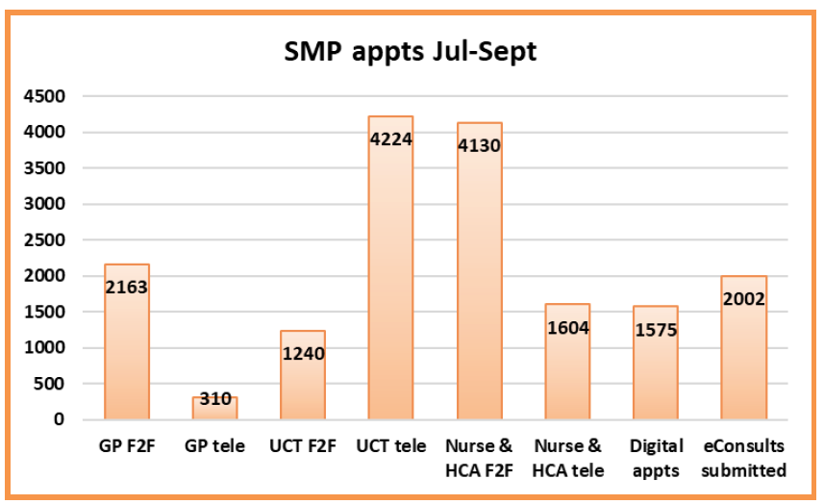

These figure do not include the appointments available via our Primary Care Network which includes physio, pharmacist, well being and social prescriber appointments.

A MESSAGE FROM OUR PPG (PATIENT PARTICIPANT GROUP)

The committee would like to give a vote of thanks to all those folk who were involved in the
recent round of covid/flu vaccinations for a job very well done. It was quick, professional and
the system worked really well. Thanks to everyone involved.

What is a Patient Participation Group?
A Patient Participation Group (PPG) is a group of people who are patients of the surgery and
want to help it work as well as it can for patients, doctors, and staff. The NHS requires every
practice to have a PPG.

How often does the PPG meet?
We meet locally, but not too often, usually 4-5 times a year. We know that you are busy but
hope that you can join us. If you can’t make meetings, then don’t worry – you can still be part of our virtual group.

What is a Virtual Group?
A virtual group is a group of patients who would like to be part of the Patient Participation Group but prefer not to attend meetings. They get involved by email instead. Information such as practice newsletters, minutes of the Patient Participation Group meetings and surveys will be shared electronically.
Why should I join?
As a patient of our surgery your experiences matter. You can bring different ideas to the
surgery to help us treat patients better or to improve what we do in some way.

Will my views be heard?
Your views are important and will be listened to. Acting on every suggestion may not be
possible, but all feedback is very valuable.

Working in a spirit of mutual respect, openness and trust, all patients' views will be discussed and, where appropriate, we will work together on solutions.

Please note that the PPG is not a forum for discussing personal cases or individual patient
circumstances. These should be raised with the appropriate member of the Stubbington
Surgery team.

For more information on the PPG and how to join please visit: www.stubbingtonmedical.co.uk/pages/Patient-Participation-Group

To contact the Patients Participation Group directly please email: ppg.stubbington@gmail.com

FLU AND COVID-19 VACCINES

As of the 16th October 2871 COVID-19 vaccines and 3258 flu vaccinations have
been given by the practice!

The majority of these where given at clinics on the 16th & 17th September where
an amazing 5491 vaccinations were given over the 2 days.

In total Coastal PCN (Stubbington Medical Practice, Lockswood Surgery & Brooklane Surgery) have given 9177 COVID-19 vaccines and are number 5 out of all sites delivering COVID vaccines in Hampshire [over 120 sites], inclusive of pharmacies, hospital hubs, other practices and PCNS.

We would like to express our gratitude to everyone who played a vital role in our vaccination clinics. From the dedicated staff and selfless volunteers who sacrificed their weekends to help protect our community, to our patients who not only showed support but also shared their kind and encouraging remarks, we deeply appreciate your contributions and commitment!

Thank you

DO MORE WITH THE NHS APP!

- Order repeat prescriptions
- Book appointments
- View your records
- And much more…

