Stubbington Medical Practice Newsletter

P R AC T I C E P A R T N E R S H I P

C H A N G E S
Some of our patients may already be aware that Dr Noel Hopkins is stepping down from the Practice Partnership on the 31st of March 2022 after more than 28 years. The great news is he will be staying on as a GP Retainer working Tuesdays and Thursdays. Dr Hopkins joined the Practice as a full time Partner on the 1st of Janu- ary 1994 and it is impossible to put an accurate figure on the thousands of patients he has helped over the years. In November 2009 Dr Hopkins became a GP Regis- trar trainer and all his registrars have benefited from his guidance, experience, and mentorship over the years to become fully fledged GPs. We as a Practice are grateful Dr Hopkins has decided to stay on and for all the years of steering the ship as senior Partner.
Dr Omar Farooqi has been with the Practice as a salaried GP since September 2021 following successful completion of GP Registrar training at a Practice in Portsmouth. Dr Farooqi will officially become a Partner on 6th April 2022 and will be changing his sessions slightly to all day Monday & Wednesday and am ses- sions Thursday & Friday. We look forward to working with him for many years to come.

NHS APP FEATURES
- Get your NHS COVID Pass
- Order repeat prescriptions
- Book appointments
- Get health advice
- View your health record
- Register your organ donation decision
- Find out how the NHS uses your data

P R E S C R I T P I O N R E Q U E ST U P DAT E

From the 1st April 2022 the practice will be updating the way patients can request prescriptions.
The Prescription team phone lines will be open from 10am-1pm & 2pm-4pm Monday to Friday.
Please use online access to order repeat prescriptions. If you do not have online access you can register via the NHS App or view our website for more details. www.stubbingtonmedical.co.uk/pages/Online-Access
Prescription request and queries can be submitted online via the practice web- site. Please see our website for more details. www.stubbingtonmedical.co.uk/pages/Repeat-Prescriptions
From the 1st of April 2022 we will no longer be accepting paper or emailed pre- scription requests. Please use the NHS app, practice website or phone line as detailed above.
Thank you

P C N ( P R I M A RY C A R E N E T W O R K )
Stubbington Medical Practice is part of the Coastal PCN along with Lockswoods and Brook Lane Surgery.
As a PCN we have developed teams of healthcare professionals, including pharmacists, home visiting nurses, community paramedic, physiotherapists, social prescribers, wellbeing coaches and other health workers to provide tailored care for patients in their community.

PCN Staff
Clinical Pharmacists -Raj Lakhpuri & Mike Mills Pharmacy Technician –Carly Matthews
Social Prescribers –Georgina Nicholls, Vicki Rowe-Shawyer
Home Visiting Service - Trish Bee (Nurse), Wendy Jones (Nurse), Clare Bennett (Nurse), Tom Sawkins (paramedic) & Heather Tregale (Frailty Lead)
First Contact Practitioners (Physio Team) - Jo Burke, Callum Dixon & Mike Gillingham Heath and Wellbeing Coaches –Diane McEwan, Vicky Green & Erin Churcher
Adult Mental Health Practitioner –Adriana Roberts

A clinician will refer patients onto our PCN teams when necessary. You can book appointments with our First Contact Practitioners Physio Team. A clinician or surgery staff can organise the social prescribers to contact you.
First Contact Practitioner
Physio appointments which are released weekdays and bookable between 8am-11:30am. Please be aware we only have a limited number of appointments daily so the earlier you call the more likely you will be successful in booking an appointment. The appointment will be a telephone appointment where you can discuss your condition with a physiotherapist, you will then be invited for face-to-face consultation, if necessary.

Social Prescribers

The Social Prescribing Team is there to listen to you, and put you in touch with the people and activities that might help your wellbeing. They can help with a range of issues including social isolation and loneliness, emotional wellbeing, loss of confi- dence/purpose, life changing events such as birth, retirement, bereavement and finances, housing and legal advice.

T H E S U R G E RY P O D
We have a Health POD in reception which can take your blood pressure, weight and height. This means you no longer have to book an appointment to have your blood pressure checked. The POD will take your readings and add them to your medical records, an alert will be sent to a clinician if any action is required from the readings.

The POD has clear instructions on the screen and attached to the blood pressure monitor. If you have any problems please see the reception team who will be able to assist you further.

C OV I D V AC C I N AT I O N S
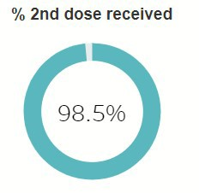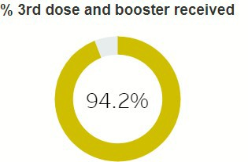
98.5% of our eligible patients have received 2 doses of the covid vaccine and 94.2% have received booster or third dose for the immunocompromised.
We would like to thank all the staff and volunteers across the PCN who helped make the COVID vaccine programme a success. Thank you to the staff who gave up countless evening and weekends and the volunteers including the PPG's of all the surgeries, we are very grateful and appreciate your time and effort at the COVID vaccine clinics.
As you may be aware the government has announced a spring booster programme which as a PCN we have started to prepare for and will be contacting eligible patients in the near future. People aged 75 years and older, residents in care homes for older people, and those aged 12 years and over with a weakened immune system will be offered a spring booster of coronavirus (COVID-19) vaccine.
APPOINTMENTS
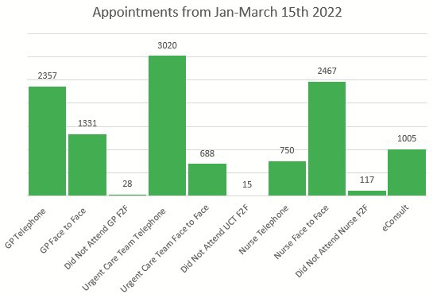So far this year we have offered pa- tients 3,688 GP appointments, 3,708 Urgent Care Team appointments, 3,155 Nurse appointments and the practice has received 1,005 eConsults. Plus numerous more appointments through our PCN team.
Sadly we also had 160 did not attends. We understand sometimes this cannot be helped but we do ask that if you know you cannot make your appoint- ment you inform the practice as soon as possible so the appointment can be reallocated to another patient.
The practice is currently looking at our appointments process and will update patients shortly.

P P G ( P AT I E N T P A R TC I P AT I O N G RO U P )
My name is Keith Houlgate and I am currently the Chair of the above group.
Being the first newsletter for a while I thought that it might be an idea to provide you with more information regarding the group.
The PPG is made up of a committee and a Virtual Group.

The PPG committee ...
- are a small group of the Practice's GP's, administration and patients who meet on a bi-monthly basis to provide an effective channel of communication between the Practice and patients.
- the membership is informal and voluntary.

The virtual group..
- are a group of patients who wish to serve on the PPG without being involved in regular meetings.
- provide two way feedback to and from the patients on issues.
Although in 2020/2021 there were no committee meetings due to covid, volunteers from the group helped the Coastal Primary Care network during the vaccination programme.
If you wish to discuss any issues with the PPG or consider joining in whatever capacity then please contact us on ppg.stubbington@gmail.com
B A N K H O L I DAYS

Thursday 2nd June — CLOSED
Friday 3rd June — CLOSED
Friday 15th April — CLOSED
Monday 18th April — CLOSED
Queen's Platinum Jubilee
Easter Bank Holiday
If you require any urgent medical assistance on these days please call 111 or visit the NHS 111 website which us www.111.nhs.uk
C O N TA C T D E TA I L S
If you change your address, mobile, telephone number or email address, please let us know so we can keep our records up to date. We now have an online form for you to send these changes to us.
This also includes if you would like a relative, carer or a nominated person to have consent to discuss your medical records and personal information.

www.stubbingtonmedical.co.uk/pages/ Consent--Change-of-Personal-Details
A R E YO U O N A WA I T I N G L I ST FO R A N
A P P O I N T M E N T , O P E R AT I O N O R T R E AT M E N T AT O N E O F O U R LO C A L H O S P I TA L S ?
The NHS has launched a new digital platform that allows patients the ability to access the latest information about the size of their waiting list through the 'My Planned Care Patient' Digital Platform'. This platform gives you direct access to the latest average wait time for your trust, as well as helpful advice and support whilst you wait.
The website is updated weekly and is easy to use. www.myplannedcare.nhs.uk/

