May 2013

Dear Patient

HAMPSHIRE HEALTH RECORD (HHR)

I am writing to give you some information on the Hampshire Health Record (HHR) so that you can make an informed decision as to whether you wish a summary of your medical information to be made available to other professionals.

The Hampshire Health Record was set up in 2004 to provide information on patients attending hospitals and out of hour’s surgeries so that health professionals could make informed clinical decisions. The majority of practices have joined the Hampshire Health Record.

Our surgery, Hampshire hospitals, social care and community care teams all collect information about you and store it electronically on separate computer systems. Once a practice joins the Hampshire Health Record summary information from all these organisations is extracted and stored in one place on a secure database. Access is restricted to registered users via the secure NHS Network and your permission is required before access by clinical staff wherever they are treating you. The data is never sent to other areas or companies outside the local NHS.

The practice information that is sent contains the codes of problems and diagnoses, drugs prescribed, clinical measurements and pathology results etc. Detailed comments are not included. Data sent to the HHR from Hampshire Hospitals includes blood test and other pathology results, X-Ray results and letters sent after Outpatient appointments or hospital admissions.

Viewing the record is only allowed with explicit consent from you. This means that you have to give permission for each person to access your record. This can be given for a once only view (i.e. at an Out Patient appointment) or for a period of time (i.e. when a Community Nurse is treating you regularly). You can change your mind about this at any time.

The only time a clinician would be able to view this information without your permission is if you were unable to give this and there was a medical reason to see your record; for example if you were unconscious after an accident. If this did happen the clinician would have to record the reason why they accessed your record without your permission. In all cases clinicians are aware that they will face disciplinary action if they misuse this service and may even lose their job.

Once the clinician has gained your consent, further controls, called Role Based Access Controls, ensures that they only see the type of information that is suitable for their job role. On occasions, in order to help interpret the results of your laboratory tests, Pathology or Radiology specialists may need to access your care record - for example to see if any medicines you are taking or if you have any pre-existing conditions which may be affecting the results. By agreeing to the test(s) you are also agreeing to the pathology specialists accessing your medical record where they feel this is appropriate.

Every time anyone accesses your record and views any part of it a record is kept of who they were and what they did. This Audit Trail is regularly reviewed and is also available for you to see. You would need to contact the HHR Operational Team in Southampton on 0300 123 1519.

Overall responsibility for the record is held by the Caldicott Guardians for the Hampshire Health Record. A Caldicott Guardian is a senior clinician or doctor who is governed by a strict set of rules and is responsible for ensuring your records are safe and only used to provide you with health care.

I hope this has answered any questions you may have on the HHR, but further information is available from leaflets available in the surgery or on-line on the Hampshire Health Record website: http://www.hantshealthrecord.nhs.uk .

Once you have made your decision, you can change your mind at any time by writing to the surgery. If you have now decided that:

- You do want your medical information made available you need not do anything. Your record will be uploaded to the HHR.

- If you do not want your medical information made available you must complete the tear off sheet below and return it to the practice. This will enable us to add a code to your record which then prevents it being available to the Hampshire Health Record.

Yours sincerely
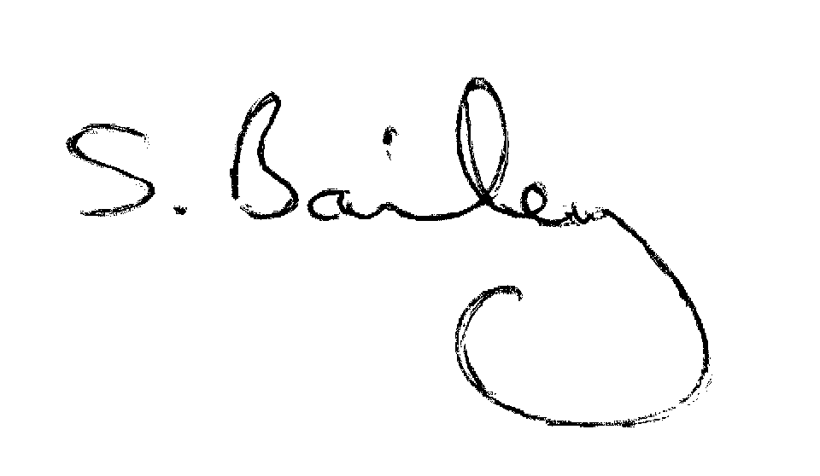
Mrs S Bailey
Practice Manager

HAMPSHIRE HEALTH RECORD – OPT OUT FORM

Name:

Address:

DOB:

I confirm that I do not give consent for my medical record held at The Stubbington Medical Practice to be uploaded to the Hampshire Health Record.

I am aware that I can change my mind, and should then write to the Practice Manager and give consent for my medical record to be included.

Signed …………………………………………. Date: …………………………………………….

Practice Action:

- Computer Care Record Summary amended to reflect No Consent for Record Sharing
- Read code 9Nd1 ‘ No consent for electronic record sharing ’ added to patient’s record.

Actioned by: Date:

