April 2012

Patients

LOCAL PATIENT REFERENCE GROUP - ACTION PLAN – UPDATED 26 APRIL 2012

To obtain the views of more of our patients we undertook a local survey during October 2011. In order to determine which questions should be included in the survey, our Patient Reference Group (PRG) reviewed the practice results of the national GP Patient Survey April 2010 – March 2011 and included questions where the practice had scored below the National average. They also suggested including additional questions that they were concerned about ie uploading patient data to the Hampshire Health Record and the condition of the premises, since they had raised these issues at previous meetings.

The questionnaires were issued from 4 October 2011 and replies required by 31 October. The practice surveyed 1,000 patients and received 823 completed questionnaires, many of which included comments about the building, car parking, toilets and access for patients unable to manage the stairs.

The comments and results of the survey were discussed with the Practice team and also with the PRG at their meetings on 29 November 2011 and 17 January 2012. On completion of the meetings the results were summarised and the following Action Plan with timescales produced.

ACTION PLAN

STATISTICS % |  |  |  |  | ACTION REQUIRED?
Forms sent out  Forms completed | 1000  823 |  | 82.3
Gender breakdown | females  males  no answer | 469  350  4 | 56.99  42.53  0.49
Ages | Under 16  17 to 24  25 to 34  35 to 44  45 to 54  55 to 64  65 to 74  75 to 84  Over 84 | 6  9  31  43  66  136  285  186  57 | 0.73  1.10  3.79  5.25  8.06  16.61  34.80  22.71  6.96
Ethnicity | White British  White Irish  White European  White & Black Caribbean  White & Black African  White & Asian  Indian  Pakistani  Bangladeshi  Caribbean  African  Chinese  Any Other  No Answer | 787  5  9  0  0  1  5  1  0  0  0  1  3  6 | 96.21  0.61  1.10  0  0  0.12  0.61  0.12  0  0  0  0.12  0.37  0.73
Q1 How regularly do you come to the practice? | Regularly  Occasionally  Very Rarely  No answer | 289  394  74  61 | 35.33  48.17  9.05  7.46
Q2 The current building is adequate for my needs | Strongly Agree  Agree  Neither Agree nor Disagree  Disagree  Strongly disagree  No Answer | 84  407  137  138  42  10 | 10.27  49.76  16.75  16.87  5.13  1.22 |  | Stairs, waiting rooms, toilets, car parking were main comments.  Meeting held on 9 Dec 11 with PCT Estates Manager who agreed to investigate what options were available to the practice in terms of extending building.  Actions:  Building Options- Awaiting a reply. Practice Manager hastened the Estates Manager 23 Feb 12 requesting an update – no response to date.  Timeframe: 30 April 2012  Phlebotomy room - Partners have agreed to go ahead with changes to Dr Murray & Phlebotomy rooms. Monfared Builder commences work Monday 2 April. To be completed by 20 April 2012.  Timeframe: Completed
Q3 I have concerns about confidentiality in the reception and waiting areas | Strongly Agree  Agree  Neither Agree nor Disagree  Disagree  Strongly disagree  No Answer | 47  194  232  270  63  12 | 5.75  23.72  28.36  33.01  7.70  1.47 |  | Patient Representative Group suggested blocking off the Inside Reception window and using the Future Appointments and current Prescription windows only for all patient enquiries & collection of prescriptions. They also suggested we remove the table and add a shelf for patients to write on if necessary.  Actions:  - Practice to check feasibility of moving computers & telephones.  - Practice to arrange for a shelf to be put up and then the table removed.  Update: On completion of building work above, quotes to be obtained for changes to reception layout.  Timeframe: 31 July 2012
Q4 The arrangements for making appointments to see a Doctor or Nurse are adequate. | Strongly Agree  Agree  Neither Agree nor Disagree  Disagree  Strongly disagree  No Answer | 84  443  111  136  34  10 | 10.27  54.16  13.57  16.63  4.16  1.22 | No action necessary.
Q5 I am satisfied with the time I have to wait for an appointment to see the Doctor of my choice. | Strongly Agree  Agree  Neither Agree nor Disagree  Disagree  Strongly disagree  No Answer | 35  258  121  279  115  10 | 4.28  31.54  14.79  34.11  14.06  1.22 | 49% not happy. The practice asked to look at appointments in more detail ie opening up the trainers appointments further ahead; look at a booking system for the downstairs room (for patients unable to go upstairs); look at breakdown of 48 hr and book ahead appointments.  Action: Options discussed at a practice meeting on 24 Feb 12 & agreed to:  - Open trainers appointments  - Breakdown is correct  - Staff to check mobility when booking upstairs GP appointments. If problem, to add alert to medical record.  - Downstairs room appointments from 1030 in a morning.  - Once phlebotomy room built, will free up Access room to revert to consultation room.  Timeframe: Completed
Q6 The system for making urgent appointments works well for me | Strongly Agree  Agree  Neither Agree nor Disagree  Disagree  Strongly disagree  No Answer | 112  411  171  78  17  29 | 13.69  50.24  20.90  9.54  2.08  3.55 | The majority were very happy with the triage system.  No action required.
Q7 I feel I am given an adequate amount of time when I see the doctor or nurse | Strongly Agree  Agree  Neither Agree nor Disagree  Disagree  Strongly disagree  No Answer | 157  531  64  46  10  10 | 19.19  64.91  7.82  5.62  1.22  1.22 | The majority of patients were happy with the length of appointments.  No action required.
Q8 The doctor or nurse listen and explain and I feel I participate in decisions | Strongly Agree  Agree  Neither Agree nor Disagree  Disagree  Strongly disagree  No Answer | 184  532  73  13  8  7 | 22.52  65.12  8.94  1.59  0.98  0.86 | The majority of patient’s were happy that they participated in decisions.  No action required.
Q9 I find it easy to obtain test results either personally or by telephone | Strongly Agree  Agree  Neither Agree nor Disagree  Disagree  Strongly disagree  No Answer | 71  451  196  52  5  42 | 8.69  55.20  23.99  6.36  0.61  5.14 | The doctor will always arrange for patients to be contacted if they have concerns over results.  No action required.
Q10 The reception staff are friendly and helpful | Strongly Agree  Agree  Neither Agree nor Disagree  Disagree  Strongly disagree  No Answer | 214  446  104  30  11  11 | 26.23  54.66  12.75  3.68  1.35  1.35 | The reception staff do a very good job in helping our patients.  Action: Customer Care training to take place in 2012  Timeframe: 30 June 2012
Q11 I am aware of the availability of appointments outside the normal working day ie early Friday morning, fortnightly on a Monday evening and monthly on a Saturday | Strongly Agree  Agree  Neither Agree nor Disagree  Disagree  Strongly disagree  No Answer | 54  324  158  181  55  44 | 6.62  39.71  19.36  22.18  6.74  5.39 | These appointments are available primarily to assist those who find it difficult to come to the surgery during our normal hours of 8am to 6pm. Their availability is published in the practice leaflet and on notices in the waiting rooms.  Action: Notices to be updated  Timeframe: Completed
Q12 I would be happy to have contact with the surgery via electronic means eg e-mails, text messages | Strongly Agree  Agree  Neither Agree nor Disagree  Disagree  Strongly disagree  No Answer | 152  316  86  129  69  64 | 18.63  38.73  10.54  15.81  8.46  7.84 | Patient consent forms are available in reception. The text messages are reminders of surgery appointments within 24 hours, thus enabling patients to cancel them if no longer required.  Prescriptions can be requested via e-mail to hamp-pct.StubbingtonScripts@nhs.net  although patients may prefer to use their local chemist who can order prescriptions on their behalf.  No action required.
Q13 Would you be interested in joining our Patient Group? If yes, please contact the surgery on 01329 664231 or e-mail PRG.stubbington@gmail.com | Yes  No  No Answer | 95  608  113 | 11.64  74.51  13.85 | Patients who e-mailed the PRG have been contacted by the secretary and have been invited to attend meetings.  No action required.
Q14 Would you be willing to be part of a group of patients that can be contacted by email for the purposes of participating in future surveys? If yes, please contact the surgery – email PRG.stubbington@gmail.com | Yes  No  No answer | 232  492  92 | 28.43  60.29  11.27 | Any e-mails received in answer to this question were added to our distribution list. Any e-mails sent out will be sent under bcc, to respect privacy of e-mail addresses.  No action required.
Q15 I would be happy for the practice to sign up to the Hampshire Health Record (The surgery, local hospitals, social care and community care teams collect information about you and store it on separate computer systems. The Hampshire Health Record stores summary information from these organisations in one place so that – with your consent- hospitals and ambulance professionals can view medical records to assist clinicians with treatment of your immediate medical needs. The information uploaded would include medication and diagnoses but not consultations or anything sensitive). Further information is available on leaflets in reception and waiting rooms. | Strongly Agree  Agree  Neither Agree nor disagree  Disagree  Strongly Disagree  No Answer | 173  442  101  39  25  36 | 21.20  54.17  12.38  4.78  3.06  4.41 | Need an information campaign before we sign up to this and a proforma so that patients can request to be excluded.  The proforma could be added to the surgery website, together with lots of information about the Hampshire Health Record to enable patients to make an informed decision. Information also to be added to the Patient Leaflet.  Action:  6 month publicity campaign. Proforma approved by Patient Representative Group and copies available in surgery and on website. Notices put up to inform patients.  Timeframe: 1 September 2012
If you wish, you may use the space below to write any comments you may have about the practice, or to make any suggestions about services or facilities you would like to see considered in the future. You may also use this space to expand on your answer to a particular question. | Answer  No answer | 255  560 | 31.29  68.71 | Car Parking – Due to lack of space, the practice is unable to make any changes to have more than 2 disabled spaces available.  No action required.  Building – We are awaiting feedback from the PCT but are aware that major changes are required downstairs.  For Information: see Q2 above.  Patient Representative Group suggested a locking mechanism at the front to secure pushchairs.  Action: Practice have provided a rail so that patients can use their own bicycle chains to secure their pushchairs.  Timeframe: COMPLETED  Improved lighting on the stairwell was also suggested by the Patient Representative Group.  Update: 21 Feb 12 – Mr Kershaw has fixed the light going up the stairs. He will also fit a different type of shade to the light outside the disabled toilet to spread the light better than the existing shade. 26 March 12 – Mr Kershaw reminded about shade.  Timeframe: 30 April 2012

The Action Plan will be e-mailed to patients, laminated copies placed in waiting rooms, be made available on our website www.stubbingtonmedical.co.uk and also on the NHS Choices website www.nhs.uk. Progress on the actions outstanding will be updated regularly.

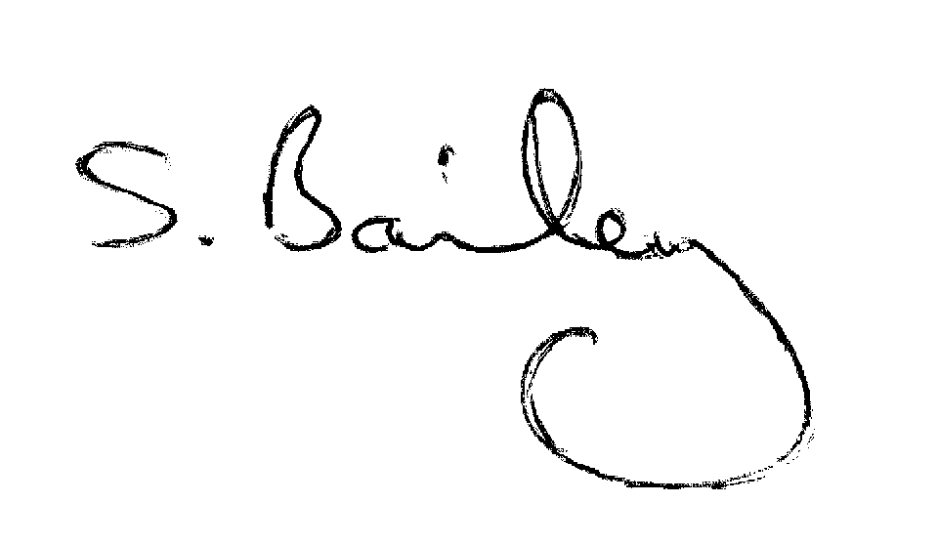

Mrs S Bailey
Practice Manager

