March 2013

Patients

LOCAL PATIENT REFERENCE GROUP - ACTION PLAN – March 2013

To obtain the views of more of our patients we undertook a local survey during October/November 2012. In order to determine which questions should be included in the survey, our Patient Reference Group (PRG) reviewed the practice results from the previous survey in October 2011 and requested that the original questions remain in order to build up a comparison. Questions were also requested to be included on Extended Hours Appointments.

The questionnaires were issued from 26 October 2012 and replies required by 14 December. The practice surveyed 500 patients and received 270 completed questionnaires, many of which included comments about the building and the appointment system.

The comments and results of the survey were discussed with the Practice team and also with the PRG at their meetings on 29 January 2013 and 18 March 2013. On completion of the meetings the results were summarised and the following Action Plan with timescales produced.

ACTION PLAN

STATISTICS  % |  |  |  | ACTION REQUIRED?
Forms sent out  Forms completed | 500  270 |  | 54%
Gender breakdown | females  males  no answer | 140  121  9 | 51.85  44.8  3.33
Ages | Under 16  17 to 24  25 to 34  35 to 44  45 to 54  55 to 64  65 to 74  75 to 84  Over 84  No answer | 0  6  13  18  32  62  90  40  2  5 | 0  2.24  4.85  6.72  11.94  23.13  33.58  14.93  0.75  1.87
Ethnicity | White British  White Irish  White European  White & Black Caribbean  White & Black African  White & Asian  Indian  Pakistani  Bangladeshi  Caribbean  African  Chinese  Any Other  No Answer | 247  2  6  1  0  0  0  0  0  1  1  1  9 | 92.16  0.75  2.24  0.37  0  0  0  0  0  0.37  0.37  0.37  3.36
How regularly do you come to the practice? | Frequently  Occasionally  Rarely  No answer | 50  162  49  5 | 18.80  60.90  18.42  1.88
Q1 The current building is adequate for my needs as a patient | Strongly Agree  Agree  Neither Agree nor Disagree  Disagree  Strongly disagree  No Answer | 16  113  61  49  21  5 | 6.04  42.64  23.02  18.49  7.92  1.89 | Stairs, waiting rooms, toilets, car parking were main comments.  The PRG acknowledged that the practice would be remaining at its current location for the foreseeable future. Therefore changes to improve the premises for the benefit of both staff and patients would be necessary.  The PRG agreed that changes would need to be made in stages  Actions: Building Options  Move the notes from the ground floor to free up space for alterations.  Timeframe: April 2014
Q2 I have concerns about confidentiality in the reception and waiting areas | Strongly Agree  Agree  Neither Agree nor Disagree  Disagree  Strongly disagree  No Answer | 26  82  68  68  14  7 | 9.81  30.94  25.66  25.66  5.28  2.64 | Relocation of Reception to improve patient confidentiality  Timeframe: October 2014  Improvements to ground floor waiting room to create a larger area, better lighting, windows, seating & wheelchair access  Timeframe: April 2015
Q3 The arrangements for making appointments to see a Doctor are adequate. | Strongly Agree  Agree  Neither Agree nor Disagree  Disagree  Strongly disagree  No Answer | 24  124  49  45  16  6 | 9.09  46.97  18.56  17.05  6.06  2.27 | No action necessary.
Q4 The arrangements for making appointments to see a Nurse are adequate. | Strongly Agree  Agree  Neither Agree nor Disagree  Disagree  Strongly disagree  No Answer | 33  162  33  18  5  12 | 12.55  61.60  12.55  6.84  1.90  4.56 | No action necessary.
Q5 I am satisfied with the time I have to wait for an appointment to see the Doctor of my choice. | Strongly Agree  Agree  Neither Agree nor Disagree  Disagree  Strongly disagree  No Answer | 4  56  47  91  59  6 | 1.52  21.29  17.87  34.6  22.4  2.28 | 56% not happy. The practice were asked to look at the breakdown of the appointments in more detail  Action: Options discussed with other Practices who all have the same problems.  The practice has the following appointments available:  Routine – can be booked well ahead  Weekly – Appointments open for the week ahead.  48 hour – Appointments open for 2 days time.  The practice has also changed the weekly appointments so that they now appear on Patient Access (on-line booking of appointments)  Timeframe: Completed
Q6 The system for making urgent appointments works well for me (known as Triage) | Strongly Agree  Agree  Neither Agree nor Disagree  Disagree  Strongly disagree  No Answer | 52  135  37  12  4  23 | 19.77  51.33  14.07  4.56  1.52  8.75 | The majority were very happy with the triage system.  No action required.
Q7 I feel I am given an adequate amount of time when I see the doctor (10 minute appointments) | Strongly Agree  Agree  Neither Agree nor Disagree  Disagree  Strongly disagree  No Answer | 49  164  21  18  4  7 | 18.63  62.36  7.98  6.84  1.52  2.66 | The majority of patients were happy with the length of appointments.  No action required.
Q8 I feel I am given an adequate amount of time when I see the nurse | Strongly Agree  Agree  Neither Agree nor Disagree  Disagree  Strongly disagree  No Answer | 44  165  30  5  1  18 | 16.73  62.74  11.41  1.90  0.38  6.84 | The majority of patients were happy with the length of appointments.  No action required.
Q9 The doctor or nurse listen and explain and I feel I participate in decisions | Strongly Agree  Agree  Neither Agree nor Disagree  Disagree  Strongly disagree  No Answer | 66  155  21  11  0  8 | 25.29  59.39  8.05  4.21  0  3.07 | The majority of patient’s were happy that they participated in decisions.  No action required.
Q10 I am happy with the amount of time I have to spend in the waiting room, waiting for my appointment. | Strongly Agree  Agree  Neither Agree nor Disagree  Disagree  Strongly disagree  No Answer | 9  81  68  74  21  8 | 3.45  31.03  26.05  28.35  8.05  3.07 | Notices have been put around the surgery by the Doctors, to apologise if patients have to wait and explaining why this sometimes happens.  No action required.
Q11 I find it easy to obtain test results either personally or by telephone | Strongly Agree  Agree  Neither Agree nor Disagree  Disagree  Strongly disagree  No Answer | 13  126  67  17  4  34 | 4.98  48.28  25.67  6.51  1.53  13.03 | The doctor will always arrange for patients to be contacted if they have concerns over results.  No action required.
Q12 The reception staff are friendly and helpful | Strongly Agree  Agree  Neither Agree nor Disagree  Disagree  Strongly disagree  No Answer | 57  131  44  13  11  5 | 21.84  50.19  16.86  4.98  4.21  1.92 | The reception staff do a very good job in helping our patients.  Action: Customer Care training to take place in 2013  Timeframe: October 2013
Q13 I am aware of the availability of appointments outside the normal working day ie early Friday morning, fortnightly on a Monday evening and monthly on a Saturday | Strongly Agree  Agree  Neither Agree nor Disagree  Disagree  Strongly disagree  No Answer | 25  145  24  40  12  15 | 9.58  55.56  9.20  15.33  4.60  5.75 | These appointments are available primarily to assist those who find it difficult to come to the surgery during our normal hours of 8am to 6pm. Their availability is published in the practice leaflet and on notices in the waiting rooms.  No action required.
Q14 I would be happy to have contact with the surgery via electronic means eg e-mails, text messages | Strongly Agree  Agree  Neither Agree nor Disagree  Disagree  Strongly disagree  No Answer | 56  141  35  16  6  7 | 21.46  54.02  13.41  6.13  2.30  2.68 | Patient consent forms are available in reception. The text messages are reminders of surgery appointments within 24 hours, thus enabling patients to cancel them if no longer required.  Prescriptions can be requested via e-mail to FGCCG.Stubbington-Scripts@nhs.net although patients may prefer to use their local chemist who can order prescriptions on their behalf & some deliver them too.  No action required.
Q15 Have you ever used the surgery website?  www.stubbingtonmedical.co.uk | Daily  Weekly  Monthly  Rarely  Never  No answer | 0  4  39  131  81  6 | 0  1.53  14.94  50.19  31.03  2.30 | This is a good source of patient information.  No action required.
Q16 How do you mainly book your appointments? (on-line is via the surgery website or patient.co.uk) | In person  By telephone  On-line (internet)  No answer | 45  162  49  5 | 17.24  62.07  18.77  1.92 | Appointments can be booked on-line via our website  www.stubbingtonmedical.co.uk  or via www.Patient.co.uk  No action required.
Q17 Do you cancel your appointment if it is no longer needed? | Yes  No  Usually  No answer | 243  1  6  11 | 93.10  0.38  2.30  4.21 | Patients sometimes forget they have appointments, but we do offer a text reminder service. Please ask at reception for a form.  No action required.
Q18 Patient Participation -  Would you be interested in joining our Patient Participation Group (PPG) when there are vacancies and attend regular meetings? If yes, please contact the Practice Manager on 01329 664231 or e-mail PPG.stubbington@gmail.com | Yes  No  No Answer | 38  149  74 | 14.56  57.09  28.35 | Patients who e-mailed the PPG have been contacted by the secretary and have been invited to attend meetings.  No action required.
Q19 Virtual Patient Participation -  Would you be willing to be part of a group of patients that can be contacted by email by the PPG. If yes please contact email Practice Manager on 01329 664231 or e-mail PPG.stubbington@gmail.com | Yes  No  No answer | 88  104  68 | 33.85  40.00  26.15 | Any e-mails received in answer to this question were added to our distribution list. Any e-mails sent out will be sent under bcc, to respect privacy of e-mail addresses.  No action required.
Q20 If you wish, you may use the space below to write any comments you may have about the practice, or to make any suggestions about services or facilities you would like to see considered in the future. You may also use this space to expand on your answer to a particular question. | Answer  No answer | 120  136 | 46.88  53.12 | The majority of comments were about appointments and issues with the building which have been answered above.  Some comments concerned the radios in the waiting rooms – these are playing to temporarily address issues of confidentiality.  Waiting times to go in for appointments was raised a few times, and we hope that with the installation of the new computer system on 17 April, the check-in system will be able to show you how long you may have to wait.  Thank you for all your positive comments on the treatment you have received from the practice staff.

The Action Plan will be e-mailed to patients, laminated copies placed in waiting rooms, be made available on our website www.stubbingtonmedical.co.uk and also on the NHS Choices website www.nhs.uk. Progress on the actions outstanding will be updated regularly.

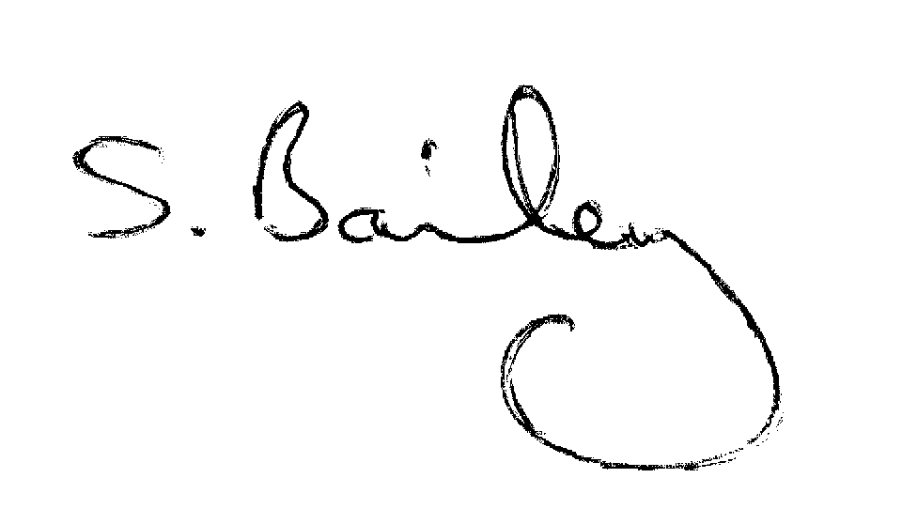

Mrs S Bailey
Practice Manager

